Name:
Date:
ScreenShot of App
Delete the example and replace with your app screen shot
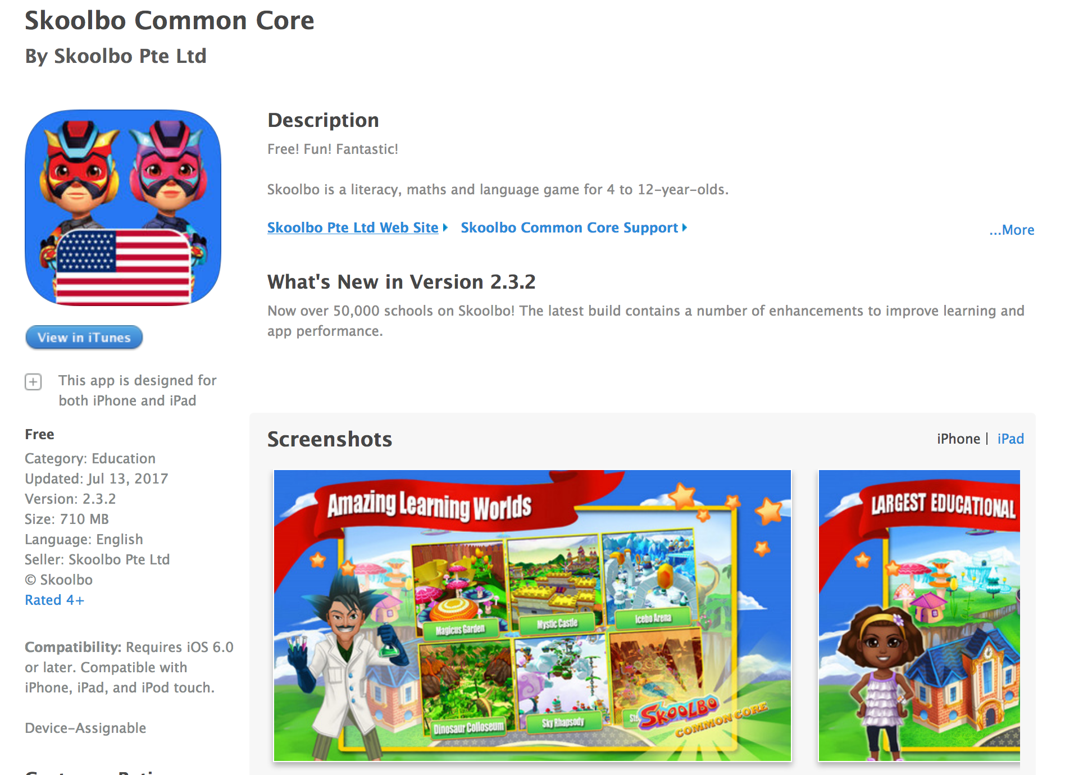

Cost: Free or ___________
NOTE: We get a discount if we purchase 25 or more licenses, otherwise we pay what is listed on the app store.

Which Devices/s? (Highlight/Circle) I-Pad or Computer or Both

Which Grade/s might use this?

How many licenses do you need?

Which Asset number/s does this app need to be put on?

